# Task No. – 06 Architecture of the FPGA to Detect Moving Objects using Principal Component Analysis (PCA) algorithm

**Date –** 16th July 2024

**Members of team:** Nichenametla Yadhu Vamsi, Rashmi Singh, Chandan Kumar, Vishesh Chhaperwal, Kush Thakur, Ranga Sudharani, Khushi Prajapati

## Abstract

The paper presents a complete implementation of the Principal Component Analysis (PCA) algorithm in Field Programmable Gate Array (FPGA) devices for high-rate background segmentation of images. The parallelization of classical sequential execution leads to specific hardware development and implementation of stages like correlation matrix computation and matrix diagonalization. The motion detection algorithm dynamically thresholds differences between input image and background model, achieving high quality segmentation results.

## Introduction

This paper presents a method for detecting moving objects based on background subtraction on the FPGA, a platform used in various computer vision applications such as video compression, vision-based control, visual surveillance, human computer interfaces, robotics, and medical imaging. The method uses a statistical background subtraction model and dynamic optimization threshold to extract foreground objects in a scene. The method is implemented on the FPGA, which offers high performance and low power, making it an efficient and attractive platform for complex applications. The method is based on a coherent word and object distance.

## PCA Algorithm

A technique called Principal Component Analysis (PCA) is applied in a variety of domains, including artificial vision, power electronics, and statistics. PCA's primary function is to eliminate redundant data, leaving just essential information (principal components).   
An excellent example of an area where the PCA technique can be directly applied is artificial vision, because images consist of many strongly linked variables (pixels). Therefore, by examining only the fundamental characteristics within the transformed space, the PCA technique may be applied to image processing to remove the redundant information of the initial variables and assess the degree of similarity between two or more images.

Detecting moving objects is the first step in breaking down video frames. Video tracking and analysis need the detection of moving objects. below figure depicts the suggested approach for detecting moving objects.   
The camera is stationary and used to record photos or video frames. An algorithm is used to recognize objects in the foreground. Out of the twenty total frames that were collected, the average of the first five frames is utilized to select the background image, and the remaining photos are used to determine the foreground object.

The proposed background subtraction algorithm detects foreground objects by comparing color regions and detecting absolute differences between red, green, and blue pixels. The algorithm calculates absolute differences for each color component and defines a dynamic threshold for binary segmentation. If the difference exceeds this threshold, the pixel is considered a foreground object, while if it's less, it's a background. The binary matrix, also known as the object map, assigns a value to each binary element.

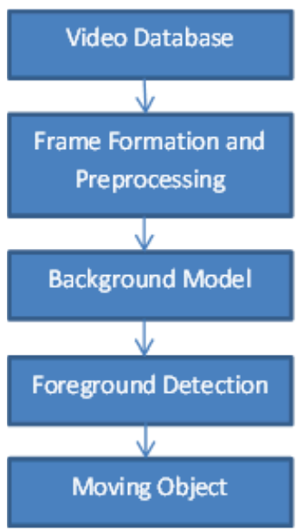

Fig.1. Proposed Algorithm

## Architecture

The proposed system uses a high-speed CMOS sensor and an FPGA for managing and capturing images, as well as executing the PCA algorithm. The system is divided into logical blocks, including a CMOS sensor controller, an image capture controller, an external memory controller, a communications controller with the PC, and a head controller. These blocks ensure the system works correctly and at maximum speed, allowing users to select specific areas of interest.

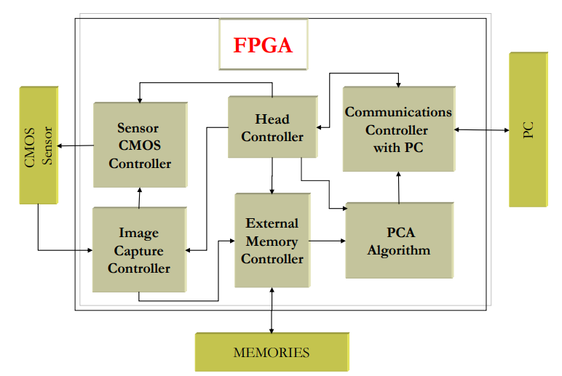

Fig.2. Block diagram of the internal architecture of the FPGA

## CONCLUSIONS

This work introduces a new image capture and processing system on FPGAs for detecting new objects in a scene. The system uses the Principal Component Analysis (PCA) technique to achieve parallel execution, achieving processing speeds of around 120 images per second. This solution is a significant improvement on other hybrid solutions using PC and FPGA, and allows for the implementation of new applications with the PCA algorithm for various applications.